THE RAIN MAKES EVERYTHING BEAUTIFUL

-Dhwani Sadaphal, BVCOE

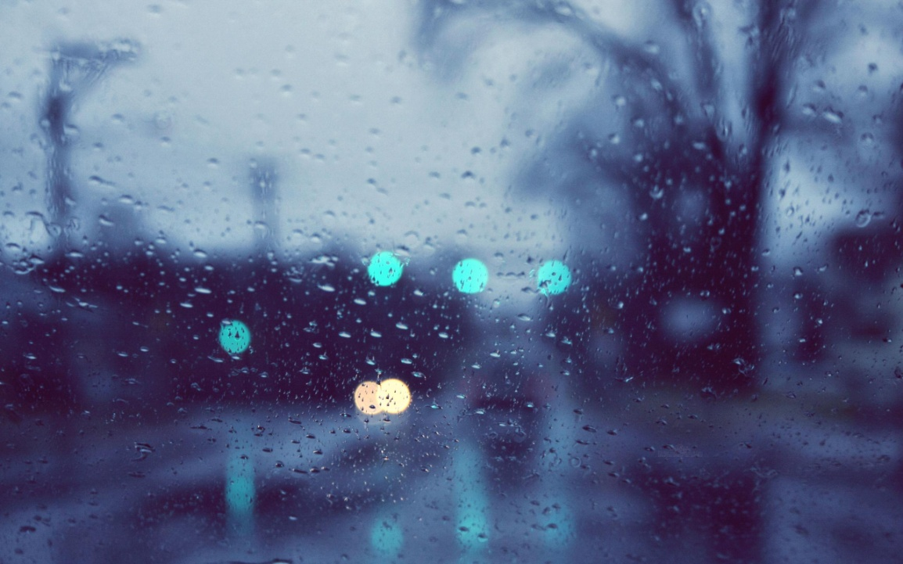

It was in the month of July. I had been going through a time when nothing seems to be happening in the right way. I wasn’t in my best spirits. I came back home after an extremely tiring day and dropped straight on the bed with hopeless thoughts brewing in my mind. I don’t know when I drifted off to sleep.

After about an hour or so, I woke up to the pitter-patter of raindrops on my window. Owing to all the negativity that had taken me over in the last few days, I thought it must be the usual five-minute spell which just ends up making the weather more humid and unbearable. But I realized I was wrong, it went on for quite some time. Just then, my brother came back home, all soaked up, and I felt like going out there and getting wet too.

I called up my friend Surabhi, she said “Aren’t you supposed to be down with fever?” to which I replied, “I was, but not anymore.” So we decided to meet up. I walked to her place, it took me just about five minutes, but by the time I reached, I was completely drenched. We went upstairs to her roof, and it was *amazing*!

It was raining cats and dogs, with the wind blowing so fast that the raindrops were like slaps on our skin. The lightning was frightening and exciting at the same time. The thunder shook the ground beneath us. We were completely drenched, shivering with cold, but I had never enjoyed the rain so much before. It reminded me of my childhood, when we used to dance in the rain, absolutely carefree. But this… this was a whole new angle. It was as if all the bitterness and negativity was just washed away. We kept saying, “This is so good!”, “Awesome”, “Best rain of my life!” and I realized how lucky I am to have a friend *crazy* enough to do this with me while, it seemed, the whole city was cursing the traffic jams and sitting at home, in front of their TV sets, missing out on what was probably the best rain spell Delhi had had in years!

We were smiling, grinning ear to ear, feeling overwhelmed, ecstatic and completely devoid of regrets. For me, this was the kind of experience which gets embedded in your memory forever. I’ll never forget this day, because it was the day that nature tried its best to lift my spirits; and when nature itself tries to make you happy, it’s hard not to be!

